**Practical 5**

**Aim:**

**5.8: JSP implicit objects**

Write 9 different jsp pages to demonstrate the use of jsp implicit objects.

out, request, response, config, application, session, pageContext, page and exception.

**Program code:**

**Page.jsp**

**<%@**page contentType="text/html" pageEncoding="UTF-8"**%>**

<!DOCTYPE html>

<html>

<head>

<meta http-equiv=**"Content-Type"** content=**"text/html; charset=UTF-8"**>

<title>**JSP Page**</title>

</head>

<body>

<h3>**Enrollment No:130050131544**</h3>

<h3>**Testing page object**</h3>

**<%**

out.print(((Servlet)page).getServletInfo());

**%>**

</body>

</html>

**Output:**

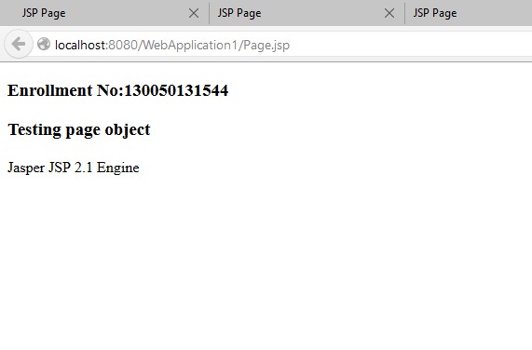

**PageContext.jsp**

**<%@**page contentType="text/html" pageEncoding="UTF-8"**%>**

<!DOCTYPE html>

<html>

<head>

<meta http-equiv=**"Content-Type"** content=**"text/html; charset=UTF-8"**>

<title>**JSP Page**</title>

</head>

<body>

<h4>**Enrollment No:130050131544**</h4>

<h4>**Testing pageContext object**</h4>

**<%**

pageContext.include("java.io.*");

**%>**

</body>

</html>

**Output:**

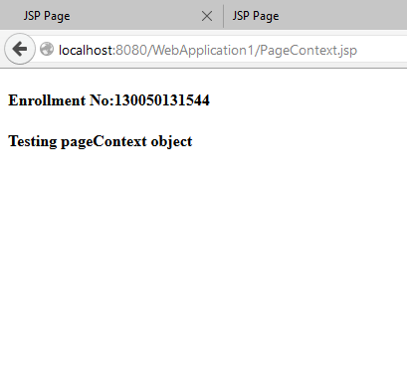

**Request.jsp**

**<%@**page contentType="text/html" pageEncoding="UTF-8"**%>**

<!DOCTYPE html>

<html>

<head>

<meta http-equiv=**"Content-Type"** content=**"text/html; charset=UTF-8"**>

<title>**JSP Page**</title>

</head>

<body>

<h4>**Enrollment No:130050131544**</h4>

<form method=**"GET"**>

<center>

**Name:**<input type=**"text"** name=**"name"** placeholder=**"Enter Name"**/><br/><br/>

<input type=**"submit"** value=**"Submit"**>

</center>

</form>

**<%**

out.print(request.getParameter("name"));

**%>**

</body>

</html>

**Output:**

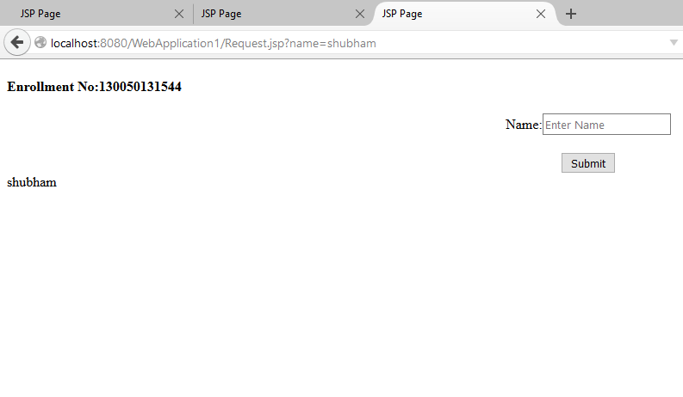

**Response.jsp**

**<%@**page contentType="text/html" pageEncoding="UTF-8"**%>**

<!DOCTYPE html>

<html>

<head>

<meta http-equiv=**"Content-Type"** content=**"text/html; charset=UTF-8"**>

<title>**JSP Page**</title>

</head>

<body>

<h4>**Enrollment No:130050131544**</h4>

<h4>**Testing Response object**</h4>

**<%**

**Boolean** x=response.isCommitted();

**if**(x==**true**){

out.println("Response is committed");

}

**else**{

out.println("Response is not committed");

}

**%>**

</body>

</html>

**Output:**

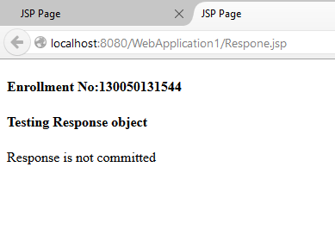

**Application.jsp**

**<%@**page contentType="text/html" pageEncoding="UTF-8"**%>**

<!DOCTYPE html>

<html>

<head>

<meta http-equiv=**"Content-Type"** content=**"text/html; charset=UTF-8"**>

<title>**JSP Page**</title>

</head>

<body>

<h4>**Enrollment No:130050131544**</h4>

<h4>**Testing Application object**</h4>

**<%**

application.setAttribute("abc","xyz");

out.println(application.getAttribute("abc"));

**%>**

</body>

</html>

**Output:**

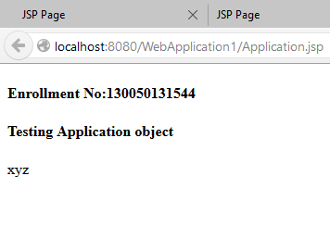

**Config.jsp**

**<%@**page contentType="text/html" pageEncoding="UTF-8"**%>**

<!DOCTYPE html>

<html>

<head>

<meta http-equiv=**"Content-Type"** content=**"text/html; charset=UTF-8"**>

<title>**JSP Page**</title>

</head>

<body>

<h3>**Enrollment No:130050131544**</h3>

<h3>**Testing Config object**</h3>

**<%**

out.println(config.getServletName());

**%>**

</body>

</html>

**Output:**

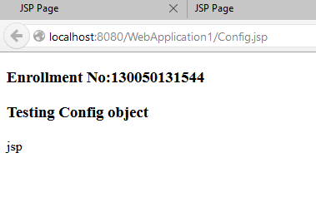

**Exception.jsp**

**<%@**page contentType="text/html" pageEncoding="UTF-8" isErrorPage="true"**%>**

<!DOCTYPE html>

<html>

<head>

<meta http-equiv=**"Content-Type"** content=**"text/html; charset=UTF-8"**>

<title>**JSP Page**</title>

</head>

<body>

<h3>**Enrollment No:130050131544**</h3>

<h3>**Testing Exception object**</h3>

<h3>**Sorry following exception occurred:<%=** exception **%>**</h3>

</body>

</html>

**Output:**

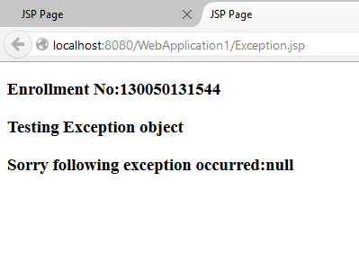

**Out.jsp**

**<%@**page contentType="text/html" pageEncoding="UTF-8"**%>**

<!DOCTYPE html>

<html>

<head>

<meta http-equiv=**"Content-Type"** content=**"text/html; charset=UTF-8"**>

<title>**JSP Page**</title>

</head>

<body>

<h3>**Enrollment No:130050131544**</h3>

**<%**

out.print("Testing out Object");

**%>**

</body>

</html>

**Output:**

